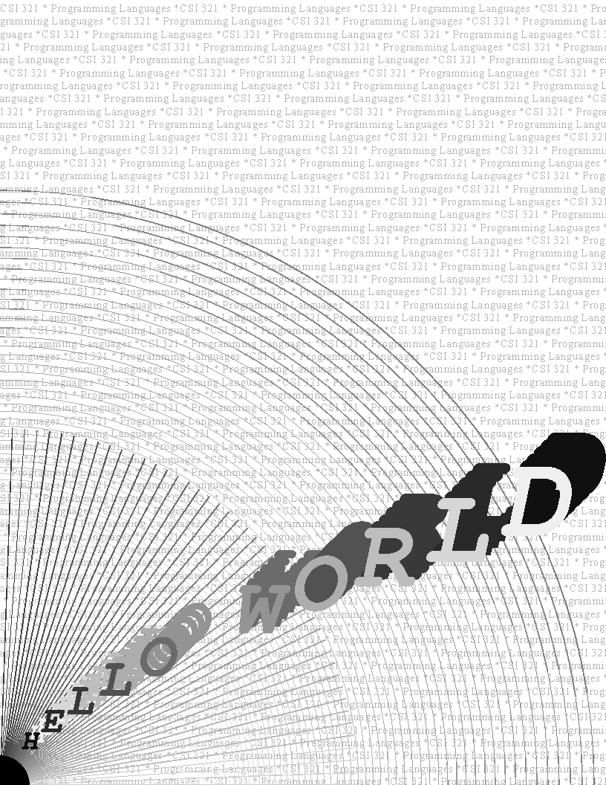
% Ghostscript Test Program - Hello World
% CS 3210
% J. Gurka
%
% Description
% This program demonstrates simple PostScript commands, which
% will be displayed by the GhostScript interpreter (or GhostView).
%
% Procedures
% DoWallPaper: print a string across the entire page, in small, light gray print
% (contains subprocedures and constants);
% expects - print string on stack, grayscale and current point (upper left) set
% DoArcs: prints variable-gray arcs with origin at (0, 0)
% DoSun: prints sun segment and rays, from origin
% DoHelloWorld: prints “Hello World”, angled from origin,
% changing grayscale and letter size, with shadowed letters

% -----------------------------------------------------------------

% DoWallPaper procedure - from PS book, pg. 89
% -- continuously writes a text string, filling the page

/DoWallPaper {
/TM 780 def % margin definitions - top, bottom, left, right
/BM -12 def
/LM 0 def
/RM 612 def

/newline % moves current point to beginning of next line
{currentpoint 13 sub
exch pop LM
exch moveto } def

/nllfNec % carriage return, line feed
{currentpoint pop RM gt
{newline} if } def

/done? % check bottom margin
{currentpoint exch pop
BM lt} def

/fillpage % print string repeatedly
{/strg exch def
{ {pop pop nllfNec} strg kshow
done? {exit} if
} loop
} def

fillpage

} def % end definition of DoWallPaper

% DoArcs procedure
% -- prints arcs oriented on (0, 0)

/DoArcs
{
gsave
0 0 moveto
.5 setgray

% loop - print successively lighter, tighter arcs, toward origin
1 1 60 {
pop
newpath
0 0 600 0 180 arc
stroke
currentgray .008 add
setgray
.98 .98 scale
} for
grestore
} def % end definition of DoArcs

% -----------------------------------------------------------------

% DoSun procedure
% -- print black sun and successively darker radial strokes from origin

/DoSun
{
% sun segment at origin
gsave
0 setgray
0 0 moveto
30 0 lineto
0 0 30 0 90 arc
0 0 lineto
closepath
fill

% sun rays from origin
.80 setgray
1 1 45 {
pop
30 0 moveto
360 0 lineto
stroke
2 rotate
currentgray .013 sub
setgray
} for
grestore
} def % end definition of DoSun

% DoHelloWorld
% -- print Hello World, diagonally, changing grayscale and font size

/DoHelloWorld
{
/scalefact 20 def
/Courier-Bold-Oblique findfont scalefact scalefont setfont

% push letters on stack
(D) (L) (R) (O) (W) ( ) (O) (L) (L) (E) (H)

% initialize variables
/strlen 11 def
/shadownum 5 def
/offsetnum 7 def

% position starting current point

20 20 moveto

% print Hello World, varying color and size and shape
/grayfact % set initial gray factor
1.0
strlen
1
add
div
def

0 setgray

% letter printing loop
1 1 strlen {
dup 15 add rmoveto % angle text up
/scalefact % increase font size
scalefact
9
add
def
/Courier-Bold-Oblique findfont
scalefact
scalefont
setfont

currentgray % decrease gray scale (1 = white)
grayfact
add
setgray

% shadow current char

1 1 shadownum {pop dup} for % duplicate character on stack
offsetnum shadownum mul dup rmoveto
1 currentgray sub setgray % flip gray
1 1 shadownum { % shadow print loop
pop
currentpoint
/oldy exch def
/oldx exch def
show
oldx oldy moveto
offsetnum neg dup rmoveto
} for

1 currentgray sub setgray % restore gray
show % print one (stacked) letter of phrase
} for
} def %end definition of DoHelloWorld

%% ====================================================================

%% "main" program
%% --------------

% print wallpaper
0 780 moveto % set starting point
.7 setgray
/Times-Roman findfont 12 scalefont setfont
(CSI 321 * Programming Languages *) % push string
DoWallPaper

% print arcs
DoArcs

% print sun
DoSun

% print Hello World
DoHelloWorld

% display result (invokes image window)
showpage

